

|  |  |
| --- | --- |
|  |  |

**Design Document**

**OOPMS**

**Thursday, June 14, 2012**

**Version 1.0**

*Prepared by*

**Ngo Duc Duy**

Revision and Signoff Sheet

Change Record

|  |  |  |  |
| --- | --- | --- | --- |
| **Date** | **Author** | **Version** | **Change reference** |
| 06/05/2012 | Ngo Duc Duy | 0.1 | Create new |
| 06/13/2012 | Ngo Duc Duy | 1.0 | Update |
|  |  |  |  |

Reviewers

|  |  |  |  |
| --- | --- | --- | --- |
| **Name** | **Version** | **Position** | **Date** |
| Manh Hoang Truong | 0.1 | Developer | 14-June-2012 |
| To Cong Thanh Hai | 0.1 | Developer | 14-June-2012 |
| Pham Nguyen Truong Giang | 0.1 | Developer | 14-June-2012 |
| Le Ngoc Thach | 0.1 | Project Manager | 14-June-2012 |

Table of Contents

1 Introduction 33

1.1 Purpose 33

1.2 Scope 33

1.3 Intended Audiences and Document Organization 33

1.4 Acronyms and Abbreviations 33

1.5 References 34

2 Architecture design 34

2.1 User case view 34

2.2 Architectural Representation 36

2.2.1 Presentation Layer 37

2.2.2 Business Layer 37

2.2.3 Data Access Layer 38

2.2.4 Data Layer 38

2.3 Packages/Components view 39

2.2.5 UI Components 39

2.2.6 Business Object 39

2.2.7 Transfer Data Objects ( Entity ) 40

2.2.8 Data Access Object 40

2.2.9 Exceptions 40

2.2.10 Utils 40

2.2.11 Logging 40

3 Technical Solutions 40

3.1 Exception handling mechanism 40

3.2 Logging mechanism 40

4 Database design 41

4.1 Entity Relationship Diagram 41

4.2 Schema 41

4.1 Detail Schema 42

5 CRC Card Model 48

6 Application Security 51

6.1 User Permission 51

6.2 Security Group 52

6.3 Main functions ‘s security matrix 52

7 Details function design 52

7.1 Requirement _UC01 - Add Requirement Use Case 52

7.1.1 Class Diagram 52

7.1.2 Sequence flow 53

7.2 Requirement _UC02 - Update Requirement Use Case 53

7.2.1 Class Diagram 53

7.2.2 Sequence flow 54

7.3 Requirement _UC03 - Delete Requirement Use Case 54

7.3.1 Class Diagram 54

7.3.2 Sequence flow 54

7.4 Requirement _UC04 - Sort Requirements Use Case 55

7.4.1 Class Diagram 55

7.4.2 Sequence flow 55

7.5 Admin _UC01 - Admin Create new Project Use Case 56

7.5.1 Class Diagram 56

7.5.2 Sequence flow 56

7.6 Admin _UC02 - Admin Search Project Use Case 57

7.6.1 Class Diagram 57

7.6.2 Sequence flow 57

7.7 Admin _UC03 - Admin Edit Project Use Case 58

7.7.1 Class Diagram 58

7.7.2 Sequence flow 58

7.8 Admin _UC04 - Admin Mange Module Use Case 58

7.8.1 Class Diagram 58

7.8.2 Sequence flow 59

7.9 Admin _UC05 - Admin Team Management Use Case 60

7.9.1 Class Diagram 60

7.9.2 Sequence flow 60

7.10 Admin _UC06 - Admin Search User Use Case 61

7.10.1 Class Diagram 61

7.10.2 Sequence flow 61

7.11 Admin _UC07 - Admin Create User Use Case 62

7.11.1 Class Diagram 62

7.11.2 Sequence flow 62

7.12 Admin _UC08 - Admin Edit User Use Case 63

7.12.1 Class Diagram 63

7.12.2 Sequence flow 63

7.13 Admin _UC09 - Admin Change User’s Status Use Case 64

7.13.1 Class Diagram 64

7.13.2 Sequence flow 64

7.14 ProjectEye _UC01 - Create new Project Use Case 65

7.14.1 Class Diagram 65

7.14.2 Sequence flow 65

7.15 ProjectEye _UC02 - Edit Project Use Case 66

7.15.1 Class Diagram 66

7.15.2 Sequence flow 66

7.16 ProjectEye _UC03 - Manage Module Use Case 67

7.16.1 Class Diagram 67

7.16.2 Sequence flow 67

7.17 ProjectEye _UC04 - Team Management Use Case 68

7.17.1 Class Diagram 68

7.17.2 Sequence flow 68

7.18 ProjectEye _UC05 - Add Risk Use Case 69

7.18.1 Class Diagram 69

7.18.2 Sequence flow 69

7.19 ProjectEye _UC06 - Edit Risk Use Case 70

7.19.1 Class Diagram 70

7.19.2 Sequence flow 70

7.20 ProjectEye _UC07 - Delete Risk Use Case 71

7.20.1 Class Diagram 71

7.20.2 Sequence flow 71

7.21 ProjectEye _UC08 - Add Issue Use Case 72

7.21.1 Class Diagram 72

7.21.2 Sequence flow 72

7.22 ProjectEye _UC09 - Edit Issue Use Case 73

7.22.1 Class Diagram 73

7.22.2 Sequence flow 73

7.23 ProjectEye _UC10 - Delete Issue Use Case 74

7.23.1 Class Diagram 74

7.23.2 Sequence flow 74

7.24 ProjectEye _UC11 - Add Change Request Use Case 75

7.24.1 Class Diagram 75

7.24.2 Sequence flow 75

7.25 ProjectEye _UC12 - Edit Change Request Use Case 76

7.25.1 Class Diagram 76

7.25.2 Sequence flow 76

7.26 ProjectEye _UC13 - Delete Change Request Use Case 77

7.26.1 Class Diagram 77

7.26.2 Sequence flow 77

7.27 ProjectEye _UC14 - Add Product Use Case 78

7.27.1 Class Diagram 78

7.27.2 Sequence flow 78

7.28 ProjectEye _UC15 - Edit Product Use Case 79

7.28.1 Class Diagram 79

7.28.2 Sequence flow 79

7.29 ProjectEye _UC16 - Delete Product Use Case 80

7.29.1 Class Diagram 80

7.29.2 Sequence flow 80

7.30 ProjectEye _UC17 - Add Stage Use Case 81

7.30.1 Class Diagram 81

7.30.2 Sequence flow 81

7.31 ProjectEye _UC18 - Edit Stage Use Case 82

7.31.1 Class Diagram 82

7.31.2 Sequence flow 82

7.32 ProjectEye _UC19 - Delete Stage Use Case 83

7.32.1 Class Diagram 83

7.32.2 Sequence flow 83

7.33 ProjectEye _UC20 - Add Deliverable Use Case 84

7.33.1 Class Diagram 84

7.33.2 Sequence flow 84

7.34 ProjectEye _UC21 - Edit Deliverable Use Case 85

7.34.1 Class Diagram 85

7.34.2 Sequence flow 85

7.35 ProjectEye _UC22 - Delete Deliverable Use Case 86

7.35.1 Class Diagram 86

7.35.2 Sequence flow 86

7.36 ProjectEye _UC23 - View Info Use Case 87

7.36.1 Class Diagram 87

7.36.2 Sequence flow 87

7.37 Planner_UC01- Filter Task Use Case 88

7.37.1 Class Diagram 88

7.37.2 Sequence Flow 88

7.38 Planner_UC02 - Add Task Use Case 89

7.38.1 Class Diagram 89

7.38.2 Sequence Flow 89

7.39 Planner_UC03 - Update Task Use Case 90

7.39.1 Class Diagram 90

7.39.2 Sequence Flow 90

7.40 Planner_UC04 - Delete Task Use Case 91

7.40.1 Class Diagram 91

7.40.2 Sequence Flow 91

7.41 Planner_UC05 - Import Task Use Case 92

7.41.1 Class Diagram 92

7.41.2 Sequence Flow 92

7.42 Dashboard _UC01 - Filter Project Use Case 93

7.42.1 Class Diagram 93

7.42.2 Sequence Flow 93

7.43 Dashboard _UC02 - Export Dashboard Use Case 94

7.43.1 Class Diagram 94

7.43.2 Sequence Flow 94

8 Interface Design 95

9 Configuration 95

10 Packaging and Deployment 95

11 Appendix 95

# Introduction

## Purpose

This document contains the detailed design for to be developed application on target platform. It defines, technically, how applications will operate. Developers will base on this document and corresponding SRS to conduct development plan, task assignment and implementation of the new application.

## Scope

This document is prepared for the application OOPMS in scope of the capstone project of FU K4B.

## Intended Audiences and Document Organization

This document is intended for:

* Development team: Developers and Testers
* Rollout Technical Team: Responsible for deploying applications to UAT and Production environments.
* Customer Representatives: Responsible to review & approve the document.

Below are main sections of the document:

* **Introduction** : This section describes the general introduction of this document
* **Architecture Design :** This section describes the high-level technical assessments and decisions for the application.
* **Technical Solutions :** This section describes mechanism used in the project.
* **Database Design**: This section describesin detail how data is structured and manipulated in this application.
* **CRC Card Model:** This is to describe modules’ responsibilities and its cooperators.
* **Application Security**: This section describles security matrix in detail
* **Detail Function Design**: This section describe in detail how features are developed and work.
* **Interface Design:** This section describesin detail how UI is designed in general ( layout , theme ).
* **Configuration:** This section describes all configuration needed for the application to function properly.
* **Packaging and Deployment:** This section describles how applications could be packaged and deployed.
* Note:Please refer section 1.4 for all acronyms and abbreviations you may encounter within this document.

## Acronyms and Abbreviations

|  |  |  |
| --- | --- | --- |
| # | Item | Description |
| 1 | ASP | ActiveX Server Page |
| 2 | JVM | Java Virtual Machine |
| 3 | HTTP | Hypertext-Transfer Protocol |
| 4 | MVC | Model – View – Control |
| 5 | DAO | Data Access Object, this object is responsible for attaching to a system, extracting some information, based on specific requirements, and creating a value object. |
| 6 | OOPMS | Open-One Project Management System |

## References

|  |  |  |  |  |
| --- | --- | --- | --- | --- |
| # | Title | Version | File Name / Link | Description |
| 1 | SRS Document | 1.0 |  |  |
| 2 | User Requirement | 1.0 |  |  |

Table 1.1: List of References

# Architecture design

## User case view

**Table of Use Case**

Overview

Main flow of Use Case

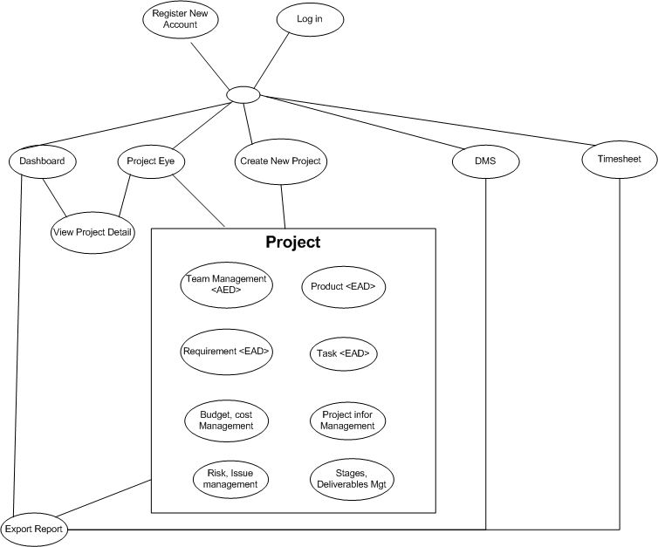

## Architectural Representation

The following diagram shows the primary tiers in the proposed n-tier architecture. This diagram shows the main layers in this architecture and the vision of how they fit together.



Figure 1 – N-tier architecture of SD System

### Presentation Layer

This layer controls the display to the end user. For the presentation layer of OOPMS, the development framework is based on MVC Model architecture. The framework is responsible for:

Managing requests/responses from/to the clients.

Controlling display to the end user.

Assembling a model that can be presented in a view.

Performing UI validation.

Providing a controller to delegate calls to business logic and other upstream processes.

Handling exceptions from other layers.

### Business Layer

This layer manages the business processing rules and logic.

Handling application business logic and business validation.

Managing transactions.

Allowing interfaces for interaction with other layers.

Managing dependencies between business level objects.

Adding flexibility between the presentation and the persistence layer so they do not directly communicate with each other.

Exposing a context to the business layer from the presentation layer to obtain business services.

Managing implementations from the business logic to the persistence layer.

### Data Access Layer

This layer manages access to persistent storage. The primary reason to separate data access from the rest of the application is that it is easier to switch data sources and share Data Access Objects (DAOs) between applications.

This layer manages reading, writing, updating, and deleting stored data.

### Data Layer

In OOPMS, the storage is managed by a relational database. Oracle 10g Express is used for this layer to provide the management of stored data.

## 2.3 Packages/Components view



### UI Components

This package includes the implementation for the JSP, MVC architecture proposed to be used in the Presentation Layer to handle the display to the end user.

**Validation**: All validation of incoming requests parameters to the server should be validated using JavaScript Validation or JSP client side control .

### Business Object

This package includes the implementation of business objects. **Business Object** (BO) layer is used to perform the business operations. The Business Object layer will access the DAO to access database. Transactions should be managed within this business layer.

### Transfer Data Objects ( Entity )

Transfer Data Objects is java class, contains lightweight structures for related business information. These are sometimes referred to as data transfer objects. A value object (VO) is a lightweight, serializable object that structures groups of data items into a single logical construct. .In addition, VOs are useful in communication among all layers of the application.

### Data Access Object

This package includes the implementation of Data Access Object. Using Oracle CLient object here to make the application more flexible to access database. Oracle Client object includes basic functions to work with database: *select, insert, update, delete*.

### Exceptions

This package will include all general exceptions that will typically used by more than one package. The try-catch clauses should be kept to a minimum.

### Utils

This package includes all utilities will be wisely used in the modules.

### Logging

This package includes implemented logging classes.

# Technical Solutions

## Exception handling mechanism

The try-catch clauses should be kept to a minimum.

Whenever an exception raise , system will log exception detail to Windows event and redirect user to Error page to display standard error message!

## Logging mechanism

Logging is an important and pretty useful mechanism for every application. It can help developers to debug and improve their code or test it’s functionality. In OOPMS, logging component is developed based on log4j logging API.

# Database design

## Entity Relationship Diagram

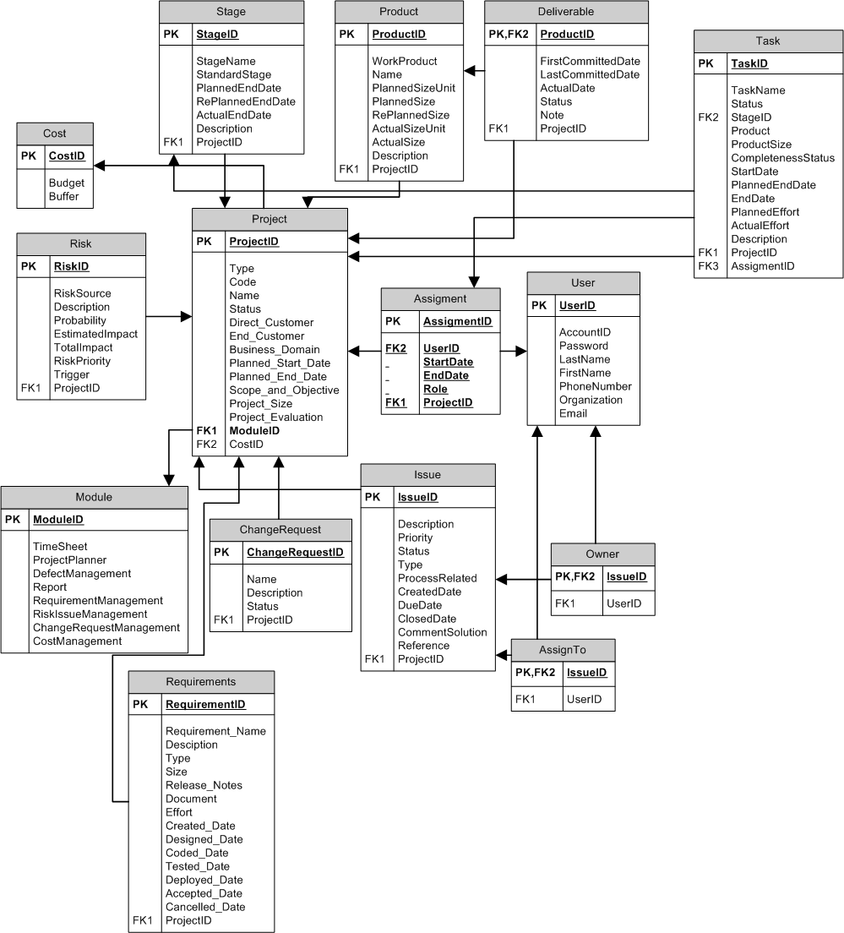

## Schema

**Overview**

|  |  |  |
| --- | --- | --- |
| **#** | **Name** | **Description** |
| 1 | Project | Project with its information: name, type, code.. |
| 2 | Stage | Stage of software development process |
| 3 | Product | Product from development process |
| 4 | Deliverable | Product to be summited to customers |
| 5 | Task | Task assign to team members |
| 6 | Cost | Cost management |
| 7 | Risk | Risk management |
| 8 | Assignment | Assignment to user |
| 9 | User | User |
| 10 | Module | Module of project |
| 11 | ChangeRequest | Change Request management |
| 12 | Issue | Issue Management |
| 13 | Owner | Owner of issue |
| 14 | AssignTo | Assigned member of issue |
| 15 | Requirement | Requirement Management |

## Detail Schema

|  |  |  |  |  |  |  |  |  |  |
| --- | --- | --- | --- | --- | --- | --- | --- | --- | --- |
| **Project table** | | | | | | | | | |
| **No** | **Field name** | **Type** | **Max Length** | | **Null** | **Unique** | **P/F Key** | **Description** | |
| 1 | ProjectID | CHAR | 10 | |  |  | PK | PK – ID of project | |
| 2 | Type | NVARCHAR | 20 | |  |  |  | Type of project | |
| 3 | Code | NVARCHAR | 20 | |  |  |  | Project code | |
| 4 | Name | NVARCHAR | 100 | |  |  |  | Name of project | | of requirement | |  | |  | |  |  |
| 5 | Status | NVARCHAR | 10 | |  |  |  | Status of project | |  | |  | |  | |  |  |
| 6 | DirectCustomer | NVARCHAR | 20 | | X |  |  | Direct customer of project | |  | |  | |  | |  |  |
| 7 | EndCustomer | NVARCHAR | 20 | | X |  |  | End customer of project | |  | |  | |  | |  |  |
| 8 | BusinessDomain | NVARCHAR | 20 | | X |  |  | Business domain of project | |  | |  | |  | |  |  |
| 9 | PlannedStartDate | DATETIME |  | |  |  |  | Planned start date of project | |  | |  | |  | |  |  |
| 10 | PlannedEndDate | DATETIME |  | |  |  |  | Planned end date of project | |  | |  | |  | |  |  |
| 11 | ScopeAndObjective | NVARCHAR | 200 | | X |  |  | Scope and objective of project | |  | |  | |  | |  |  |
| 12 | ProjectSize | INTEGER |  | | X |  |  | Size of project | |  | |  | |  | |  |  |
| 13 | ProjectEvaluation | INTEGER |  | | X |  |  | Project Evaluation | |  | |  | |  | |  |  |
| 14 | ModuleID | CHAR | 10 | |  |  | FK | FK ModuleID of project | |  | |  | |  | |  |  |
| 15 | CostID | CHAR | 10 | |  |  | FK | FK CostID of project | |  | |  | |  | |  |  |
|  | | | |  | | | | |  | |  | |  | |
| **Stage table** | | | | | | | | | |
| **No** | **Field name** | **Type** | **Max Length** | | **Null** | **Unique** | **P/F Key** | **Description** | |
| 1 | StageID | CHAR | 10 | |  |  | PK | PK – ID of stage | |
| 2 | StageName | NVARCHAR | 20 | |  |  |  | Name of stage | |
| 3 | StandardStage | NVARCHAR | 20 | |  |  |  | Standard Stage | |
| 4 | PlannedEndDate | DATETIME |  | |  |  |  | Planned end date of stage | |
| 5 | RePlannedEndDate | DATETIME |  | | X |  |  | Re planned end date of stage | |
| 6 | ActualEndDate | DATETIME |  | | X |  |  | Actual end date of stage | |
| 7 | Description | NVARCHAR | 200 | | X |  |  | Description of stage | |
| 8 | DelFlag | BOOLEAN |  | |  |  |  | Deleted flag of stage | |
| 9 | ProjectID | CHAR | 10 | |  |  | FK | FK ProjectID of stage | |
|  | | | |  | | | | |  | |
| **Product table** | | | | | | | | | |
| **No** | **Field name** | **Type** | **Max Length** | | **Null** | **Unique** | **P/F Key** | **Description** | |
| 1 | ProductID | CHAR | 10 | |  |  | PK | PK – ID of product | |
| 2 | WorkProduct | NVARCHAR | 20 | |  |  |  | Work of product | |
| 3 | Name | NVARCHAR | 20 | |  |  |  | Name of product | |
| 4 | PlannedSizeUnit | NVARCHAR | 20 | |  |  |  | Planned size unit of product | | of requirement | |  | |  | |  |  |
| 5 | PlannedSize | INTEGER |  | |  |  |  | Planned size of product | |  | |  | |  | |  |  |
| 6 | RePlannedSize | INTEGER |  | | X |  |  | Re planned size of product | |  | |  | |  | |  |  |
| 7 | ActualSizeUnit | NVARCHAR | 20 | | X |  |  | Actual size unit of product | |  | |  | |  | |  |  |
| 8 | ActualSize | INTEGER |  | | X |  |  | Actual size of product | |  | |  | |  | |  |  |
| 9 | Description | NVARCHAR | 200 | | X |  |  | Description of product | |  | |  | |  | |  |  |
| 10 | DelFlag | BOOLEAN |  | |  |  |  | Deleted flag of product | |
| 11 | ProjectID | CHAR | 10 | |  |  | FK | FK ProjectID of product | |  | |  | |  | |  |  |
|  | | | |  | | | | |  | |  | |  | |

|  |  |  |  |  |  |  |  |  |  |
| --- | --- | --- | --- | --- | --- | --- | --- | --- | --- |
| **Deliverable table** | | | | | | | | | |
| **No** | **Field name** | **Type** | **Max Length** | | **Null** | **Unique** | **P/F Key** | **Description** | |
| 1 | ProductID | CHAR | 10 | |  |  | PK/FK | PK – ID of deliverable | |
| 2 | FirstCommittedDate | DATETIME |  | |  |  |  | First committed date of deliverable | |
| 3 | LastCommittedDate | DATETIME |  | | X |  |  | Last committed date of deliverable | |
| 4 | ActualDate | DATETIME |  | | X |  |  | Actual date of deliverable | | of requirement | |  | |  | |  |  |
| 5 | Status | NVARCHAR | 20 | |  |  |  | Status of deliverable | |  | |  | |  | |  |  |
| 6 | Note | NVARCHAR | 200 | | X |  |  | Note of deliverable | |  | |  | |  | |  |  |
| 7 | DelFlag | BOOLEAN |  | |  |  |  | Deleted flag of deliverable | |
| 8 | ProjectID | CHAR | 10 | |  |  | FK | FK ProjectID of deliverable | |  | |  | |  | |  |  |
|  | | | |  | | | | |  | |  | |  | |

|  |  |  |  |  |  |  |  |
| --- | --- | --- | --- | --- | --- | --- | --- |
| **Risk table** | | | | | | | |
| **No** | **Field name** | **Type** | **Max Length** | **Null** | **Unique** | **P/F Key** | **Description** |
| 1 | RiskID | CHAR | 10 |  |  | PK | PK – ID of risk |
| 2 | RiskSource | NVARCHAR | 50 |  |  |  | Source of risk |
| 3 | Description | NVARCHAR | 200 |  |  |  | Description of risk |
| 4 | Probability | INTEGER |  |  |  |  | Probability of risk | of requirement |  |  |  |  |
| 5 | EstimatedImpact | NVARCHAR | 10 |  |  |  | Estimated impact of risk |  |  |  |  |  |
| 6 | TotalImpact | INTEGER |  | X |  |  | Total Impact of risk |  |  |  |  |  |
| 7 | RiskPriority | INTEGER |  |  |  |  | Priority of risk |  |  |  |  |  |
| 8 | Trigger | NVARCHAR | 200 | X |  |  | Trigger of risk |  |  |  |  |  |
| 9 | DelFlag | BOOLEAN |  |  |  |  | Deleted flag of risk |
| 10 | ProjectID | CHAR | 10 |  |  | FK | FK ProjectID of risk |  |  |  |  |  |

|  |  |  |  |  |  |  |  |
| --- | --- | --- | --- | --- | --- | --- | --- |
| **Issue table** | | | | | | | |
| **No** | **Field name** | **Type** | **Max Length** | **Null** | **Unique** | **P/F Key** | **Description** |
| 1 | IssueID | CHAR | 10 |  |  | PK | PK – ID of issue |
| 2 | Description | NVARCHAR | 20 |  |  |  | Description of issue |
| 3 | Priority | NVARCHAR | 20 |  |  |  | Priority of issue |
| 4 | Status | NVARCHAR | 10 |  |  |  | Status of issue | of requirement |  |  |  |  |
| 5 | Type | NVARCHAR | 10 |  |  |  | Type of issue |  |  |  |  |  |
| 6 | ProcessRelated | NVARCHAR | 20 |  |  |  | Process related to issue |  |  |  |  |  |
| 7 | CreatedDate | NVARCHAR | 20 |  |  |  | Create date of issue |  |  |  |  |  |
| 8 | DueDate | NVARCHAR | 20 |  |  |  | Due date of issue |  |  |  |  |  |
| 9 | ClosedDate | DATETIME |  | X |  |  | Closed date of issue |  |  |  |  |  |
| 10 | CommentSolution | DATETIME |  | X |  |  | Comment solution for issue |  |  |  |  |  |
| 11 | Reference | NVARCHAR | 200 | X |  |  | Reference of issue |  |  |  |  |  |
| 12 | DelFlag | BOOLEAN |  |  |  |  | Deleted flag of issue |
| 13 | ProjectID | CHAR | 10 |  |  | FK | FK ProjectID of issue |  |  |  |  |  |

|  |  |  |  |  |  |  |  |
| --- | --- | --- | --- | --- | --- | --- | --- |
| **ChangeRequest table** | | | | | | | |
| **No** | **Field name** | **Type** | **Max Length** | **Null** | **Unique** | **P/F Key** | **Description** |
| 1 | ChangeRequestID | CHAR | 10 |  |  | PK | PK – ID of change request |
| 2 | Name | NVARCHAR | 20 |  |  |  | Name of change request |
| 3 | Description | NVARCHAR | 200 |  |  |  | Description of change request |
| 4 | Status | NVARCHAR | 10 |  |  |  | Status of change request | of requirement |  |  |  |  |
| 5 | DelFlag | BOOLEAN |  |  |  |  | Deleted flag of change request |
| 6 | ProjectID | CHAR | 10 |  |  | FK | FK ProjectID of issue |  |  |  |  |  |

|  |  |  |  |  |  |  |  |
| --- | --- | --- | --- | --- | --- | --- | --- |
| **Module table** | | | | | | | |
| **No** | **Field name** | **Type** | **Max Length** | **Null** | **Unique** | **P/F Key** | **Description** |
| 1 | ModuleID | CHAR | 10 |  |  | PK | PK – ID of Module |
| 2 | TimeSheet | BOOLEAN |  |  |  |  | Usage of time sheet |
| 3 | ProjectPlanner | BOOLEAN |  |  |  |  | Usage of project planner |
| 4 | DefectManagement | BOOLEAN |  |  |  |  | Usage of defect management | of requirement |  |  |  |  |
| 5 | Report | BOOLEAN |  |  |  |  | Usage of report |  |  |  |  |  |
| 6 | RequirementManagement | BOOLEAN |  |  |  |  | Usage of requirement management |  |  |  |  |  |
| 7 | RiskIssueManagement | BOOLEAN |  |  |  |  | Usage of risk issue management |  |  |  |  |  |
| 8 | ChangeRequestManagement | BOOLEAN |  |  |  |  | Usage of change request management |  |  |  |  |  |
| 9 | CostManagement | BOOLEAN |  |  |  |  | Usage of cost management |  |  |  |  |  |

|  |  |  |  |  |  |  |  |
| --- | --- | --- | --- | --- | --- | --- | --- |
| **Owner table** | | | | | | | |
| **No** | **Field name** | **Type** | **Max Length** | **Null** | **Unique** | **P/F Key** | **Description** |
| 1 | IssueID | CHAR | 10 |  |  | PK/FK | PK/FK – ID of Owner From IssueID of Issue table |
| 2 | UserID | CHAR | 10 |  |  | FK | FK UserID of Owner |

|  |  |  |  |  |  |  |  |
| --- | --- | --- | --- | --- | --- | --- | --- |
| **AssignTo table** | | | | | | | |
| **No** | **Field name** | **Type** | **Max Length** | **Null** | **Unique** | **P/F Key** | **Description** |
| 1 | IssueID | CHAR | 10 |  |  | PK/FK | PK/FK – ID of AssignTo From IssueID of Issue table |
| 2 | UserID | CHAR | 10 |  |  | FK | FK UserID of AssignTo |

|  |  |  |  |  |  |  |  |
| --- | --- | --- | --- | --- | --- | --- | --- |
| **User table** | | | | | | | |
| **No** | **Field name** | **Type** | **Max Length** | **Null** | **Unique** | **P/F Key** | **Description** |
| 1 | UserID | CHAR | 10 |  |  | PK | PK – ID of user |
| 2 | AccountID | NVARCHAR | 20 |  | X |  | AccountID of user |
| 3 | Password | NVARCHAR | 20 |  |  |  | Password of user |
| 4 | LastName | NVARCHAR | 10 |  |  |  | Last name of user | of requirement |  |  |  |  |
| 5 | FirstName | NVARCHAR | 20 |  |  |  | First name of user |  |  |  |  |  |
| 6 | PhoneNumber | NVARCHAR | 20 | X |  |  | Phone number of user |  |  |  |  |  |
| 7 | Organization | NVARCHAR | 20 | X |  |  | Organization of user |  |  |  |  |  |
| 8 | Email | NVARCHAR | 20 | X |  |  | Email of user |  |  |  |  |  |
| 9 | DelFlag | BOOLEAN |  |  |  |  | Deleted flag of user |
| 10 | Status | BOOLEAN |  |  |  |  | Status of user (active/inactive) |

|  |  |  |  |  |  |  |  |
| --- | --- | --- | --- | --- | --- | --- | --- |
| **Assigment table** | | | | | | | |
| **No** | **Field name** | **Type** | **Max Length** | **Null** | **Unique** | **P/F Key** | **Description** |
| 1 | AssignmentID | CHAR | 10 |  |  | PK | PK – ID of assignment |
| 2 | UserID | CHAR | 10 |  |  | FK | FK UserID of assignment |
| 3 | StartDate | DATETIME |  |  |  |  | Start date of assignment |
| 4 | EndDate | DATETIME |  | X |  |  | End date of assignment | of requirement |  |  |  |  |
| 5 | Role | NVARCHAR | 20 |  |  |  | Role of user in this assignment |  |  |  |  |  |
| 6 | DelFlag | BOOLEAN |  |  |  |  | Deleted flag of assigment |
| 7 | ProjectID | CHAR | 10 |  |  | FK | FK ProjectID of assignment |  |  |  |  |  |

|  |  |  |  |  |  |  |  |
| --- | --- | --- | --- | --- | --- | --- | --- |
| **Cost table** | | | | | | | |
| **No** | **Field name** | **Type** | **Max Length** | **Null** | **Unique** | **P/F Key** | **Description** |
| 1 | CostID | CHAR | 10 |  |  | PK | PK – ID of cost |
| 2 | Budget | INTEGER |  |  |  |  | Budget of project |
| 3 | Buffer | INTEGER |  |  |  |  | Buffer of project |

|  |  |  |  |  |  |  |  |  |  |
| --- | --- | --- | --- | --- | --- | --- | --- | --- | --- |
| **Task table** | | | | | | | | | |
| **No** | **Field name** | **Type** | **Max Length** | | **Null** | **Unique** | **P/F Key** | **Description** | |
| 1 | TaskID | CHAR | 10 | |  |  | PK | ID of task | |
| 2 | TaskName | NVARCHAR | 100 | |  |  |  | Name of task | |
| 3 | Status | INTEGER |  | |  |  |  | Status of task | |
| 4 | AssignmentID | CHAR | 10 | | X |  | FK | ID of assignment table (to get users belong to the project) | | of requirement | |  | |  | |  |  |
| 5 | StageID | CHAR | 10 | | X |  | FK | ID of stage that task belong to | |  | |  | |  | |  |  |
| 6 | Product | INTEGER |  | | X |  |  | Product of task (LOC, page…) | |  | |  | |  | |  |  |
| 7 | ProductSize | INTEGER |  | | X |  |  | Size of product | |  | |  | |  | |  |  |
| 8 | CompletenessStatus | INTEGER |  | | X |  |  | Number of completed products | |  | |  | |  | |  |  |
| 9 | StartDate | DATETIME |  | | X |  |  | Start date of task | |  | |  | |  | |  |  |
| 10 | PlannedEndDate | DATETIME |  | | X |  |  | Planned end date of task | |  | |  | |  | |  |  |
| 11 | EndDate | DATETIME |  | | X |  |  | Actual end date of task | |  | |  | |  | |  |  |
| 12 | PlannedEffort | INTEGER |  | | X |  |  | Planned effort of task | |  | |  | |  | |  |  |
| 13 | ActualEffort | INTEGER |  | | X |  |  | Actual effort of task | |  | |  | |  | |  |  |
| 14 | Description | NVARCHAR | 200 | | X |  |  | Description of task | |  | |  | |  | |  |  |
| 15 | ProjectID | CHAR | 10 | |  |  | FK | ID of project that task belong to | |  | |  | |  | |  |  |
| 16 | Active | BOOLEAN |  | |  |  |  | Deleted state of task | |  | |  | |  | |  |  |
|  | | | |  | | | | |  | |  | |  | |

|  |  |  |  |  |  |  |  |
| --- | --- | --- | --- | --- | --- | --- | --- |
| **Requirements table** | | | | | | | |
| **No** | **Field name** | **Type** | **Max Length** | **Null** | **Unique** | **P/F Key** | **Description** |
| 1 | RequirementID | String | 10 |  |  | P | PK – ID of requirement |
| 2 | Description | String | 200 |  |  |  | Short description of requirement |
| 3 | Type | String | (new, change request) |  |  |  | Type of requirement |
| 4 | Size | int | (1,2,3,4,5) |  |  |  | Size of requirement |
| 5 | Release_Notes | String | 200 | X |  |  | Notes of requirement |
| 6 | Document | String | 200 |  |  |  | Doc link of requirement |
| 7 | Effort | Int | N/A | X |  |  | Effort of requirement |
| 8 | Created_Date | Date | N/A | X |  |  | Created date of requirement |
| 9 | Designed_Date | Date | N/A | X |  |  | Designed date of requirement |
| 10 | Coded_Date | Date | N/A | X |  |  | Coded date of requirement |
| 11 | Tested_Date | Date | N/A | X |  |  | Tested date of requirement |
| 12 | Deployed_Date | Date | N/A | X |  |  | Deployed date of requirement |
| 13 | Accepted_Date | Date | N/A | X |  |  | Accepted date of requirement |
| 14 | Cancelled_Date | Date | N/A | X |  |  | Cancelled date of requirement |
| 15 | ProjectID | String | 10 |  |  | F | FK ProjectID of requirement |
| 16 | Status | String | (open, designed, coded, tested, accepted, deployed, released, cancelled) |  |  |  | Status of requirement |
| 17 | Active | Boolean |  |  |  |  | Active or inactive |

# CRC Card Model

**Basic User Scenario**

1. Project Manager create new project.
2. PM manages team; add Products, Tasks, and Requirements…
3. Project Management includes schedule, progress, cost, risk, issue…
4. PM, member use DMS, Timesheet system.
5. Control, monitor, and update Project Status.

Notes: These are not fully documented user stories. More is needed, but these should give you an idea.

|  |  |
| --- | --- |
| **Dashboard Controller Class** | |
| Responsibilities | Collaborators |
| 1. Provide overall information about projects ‘status including name, health, cost, progress, quality, efficiency, date, effort. 2. Allow user to filter projects by status, category, date, cost, progress, efficiency. 3. Allow user to sort projects by name, date, project manager. 4. Provide link to project detail information and export feature. | Project Class  Planner Class  Cost Class  DMS Class  Timesheet Class |

|  |  |
| --- | --- |
| **Planner Controller Class** | |
| Responsibilities | Collaborators |
| 1. Allow project manager to manage tasks: add new task, update, delete, assign, monitor progress, completeness rate, and date. 2. Feature filter projects by status, assigned to. 3. Allow user to sort status, date, assigned to. 4. Import feature using Microsoft Project and export report. 5. Team members can update tasks’ progress. | Project Class  User Class  Stage Class  Product Class |

|  |  |
| --- | --- |
| **Project Controller Class** | |
| Responsibilities | Collaborators |
| 1. Team Management 2. Project Module Management 3. Cost 4. Product 5. Schedule 6. Progress 7. Risk, Issue, Change Request | Stage Class  Product Class  User Class  Risk Class  Issue Class  Requirement Class  Deliverable Class |

|  |  |
| --- | --- |
| **Report Controller Class** | |
| Responsibilities | Collaborators |
| 1. Project information 2. Planner 3. DMS 4. Timesheet | Project Class  Planner Class  DMS Class  Timesheet Class |

|  |  |
| --- | --- |
| **Timesheet Controller Class** | |
| Responsibilities | Collaborators |
| 1. Allow project manager to monitor timework and effort of team member. 2. Feature filter projects by date, status, project. 3. Team members can log timesheet as their works daily or weekly. | Project Class  User Class  Product Class  Stage Class |

|  |  |
| --- | --- |
| **DMS Controller Class** | |
| Responsibilities | Collaborators |
| 1. Allow project manager to monitor defect and fix bug effort of team. 2. Feature filter projects by date, status, and project, creator, assigned to. 3. Team members can update defect status. | Project Class  User Class |

|  |  |
| --- | --- |
| **Requirement Controller Class** | |
| Responsibilities | Collaborators |
| 1. Managing feature enables user to store and manage their requirement documents. 2. Including: Add, update, remove, sort 3. User interface allows user to sort requirement by type, date, priority. 4. Display completeness rate updated by user. | Project Class  Product Class |

|  |  |
| --- | --- |
| **User Admin Controller Class** | |
| Responsibilities | Collaborators |
| 1. Manage Project 2. Manage User 3. Manage Project Team 4. Manage Project Module 5. Change User’s Information 6. Reset Password 7. Manage Project 8. Manage Project Team 9. Manage Project Module 10. Manage Cost 11. Manage Product 12. Manage Work Order 13. Manage Risk, Issue, Change Request | User Class  Project Class |

|  |  |
| --- | --- |
| **Dashboard Class** | |
| Responsibilities | Collaborators |
| Represent information of projects on system. |  |

|  |  |
| --- | --- |
| **Planner Class** | |
| Responsibilities | Collaborators |
| Representation information of project’s tasks |  |

|  |  |
| --- | --- |
| **Project Class** | |
| Responsibilities | Collaborators |
| Representation information of project |  |

|  |  |
| --- | --- |
| **Report Class** | |
| Responsibilities | Collaborators |
| Representation information of project’s reports |  |

|  |  |
| --- | --- |
| **Timesheet Class** | |
| Responsibilities | Collaborators |
| Representation information of project’s timesheet |  |

|  |  |
| --- | --- |
| **DMS Class** | |
| Responsibilities | Collaborators |
| Representation information of project’s DMS |  |

|  |  |
| --- | --- |
| **Requirement Class** | |
| Responsibilities | Collaborators |
| Representation information of project’s requirements |  |

|  |  |
| --- | --- |
| **User Class** | |
| Responsibilities | Collaborators |
| Representation information of user on system |  |

|  |  |
| --- | --- |
| **Product Class** | |
| Responsibilities | Collaborators |
| Representation information of products of project |  |

|  |  |
| --- | --- |
| **Stage Class** | |
| Responsibilities | Collaborators |
| Representation information of stages of project |  |

|  |  |
| --- | --- |
| **Risk Class** | |
| Responsibilities | Collaborators |
| Representation information of risks of project |  |

|  |  |
| --- | --- |
| **Issue Class** | |
| Responsibilities | Collaborators |
| Representation information of issues of project | Project Class |

|  |  |
| --- | --- |
| **Deliverable Class** | |
| Responsibilities | Collaborators |
| Representation state of products of project |  |

# Application Security

## User Permission

|  |  |
| --- | --- |
| **Name** | **Permission** |
| System Admin | New, Read , Edit Users, Project |
| User | Read, Edit |
| Project Full Control | New, Read, Edit,Delete |
| No Acess | N/A |

## Security Group

|  |  |
| --- | --- |
| Name | **Description** |
| [Setup.Admin] | Administrator is responsible to manage system, users, projects. |
| [User] | User can be member or PM of a project. |
| [Project.Manager] | PMs are allowed to have full access to their projects. |

## Main functions ‘s security matrix

To be updated.

# Details function design

## Requirement _UC01 - Add Requirement Use Case

### Class Diagram

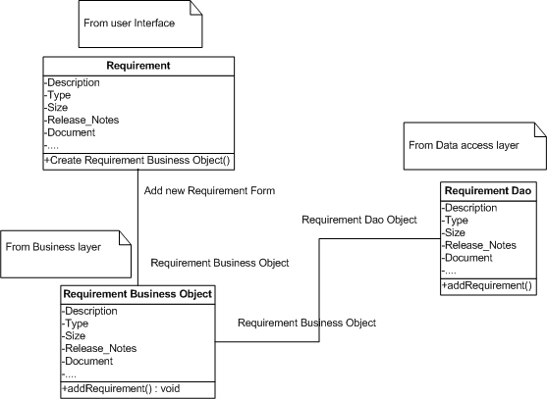

### Sequence flow

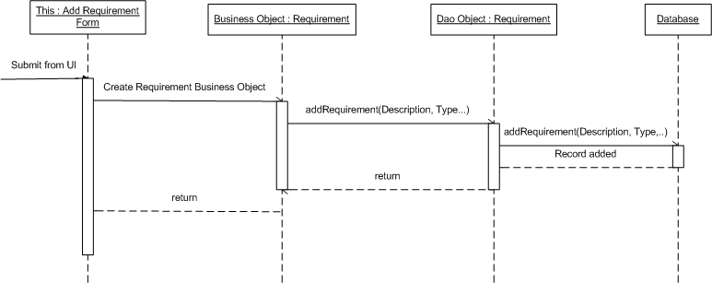

## Requirement _UC02 - Update Requirement Use Case

### Class Diagram

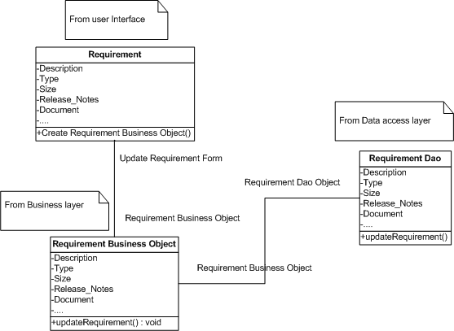

### Sequence flow

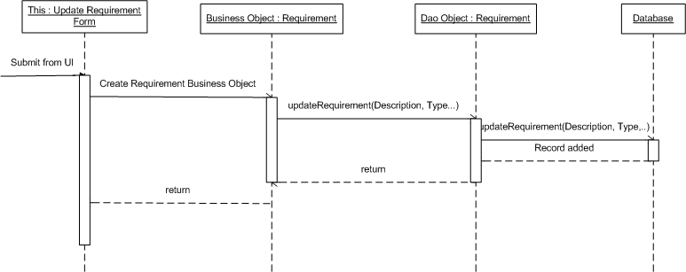

## Requirement _UC03 - Delete Requirement Use Case

### Class Diagram

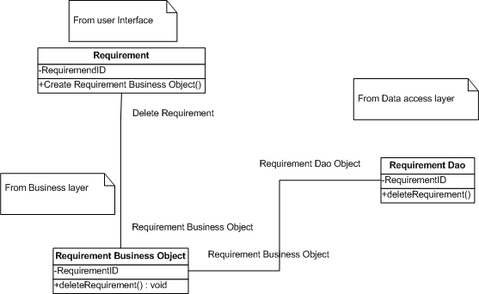

### Sequence flow

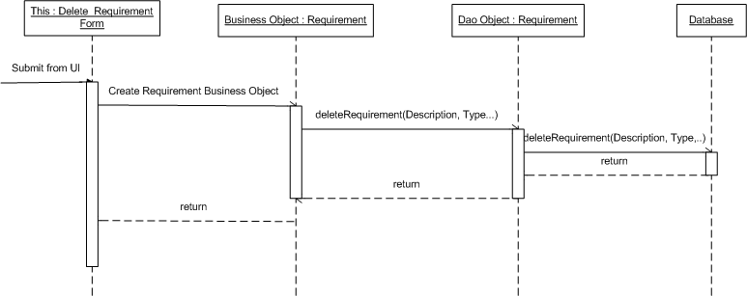

## Requirement _UC04 - Sort Requirements Use Case

### Class Diagram

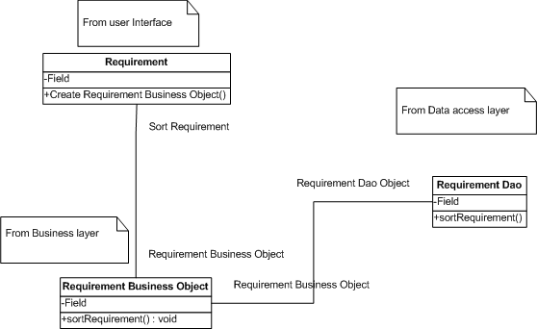

### Sequence flow

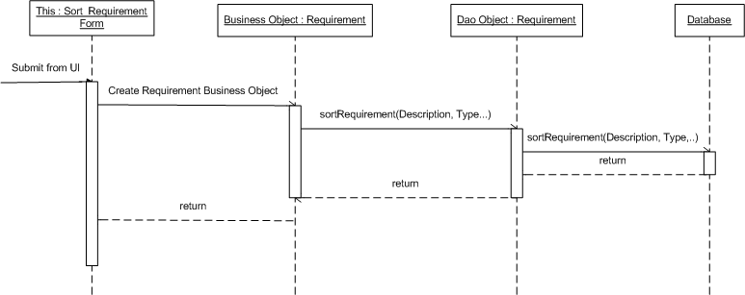

## Admin _UC01 - Admin Create new Project Use Case

### Class Diagram



### Sequence flow



## Admin _UC02 - Admin Search Project Use Case

### Class Diagram



### Sequence flow



## Admin _UC03 - Admin Edit Project Use Case

### Class Diagram



### Sequence flow



## Admin _UC04 - Admin Mange Module Use Case

### Class Diagram



### Sequence flow



## Admin _UC05 - Admin Team Management Use Case

### Class Diagram



### Sequence flow



## Admin _UC06 - Admin Search User Use Case

### Class Diagram



### Sequence flow



## Admin _UC07 - Admin Create User Use Case

### Class Diagram



### Sequence flow



## Admin _UC08 - Admin Edit User Use Case

### Class Diagram



### Sequence flow



## Admin _UC09 - Admin Change User’s Status Use Case

### Class Diagram



### Sequence flow



## ProjectEye _UC01 - Create new Project Use Case

### Class Diagram



### Sequence flow



## ProjectEye _UC02 - Edit Project Use Case

### Class Diagram



### Sequence flow



## ProjectEye _UC03 - Manage Module Use Case

### Class Diagram



### Sequence flow



## ProjectEye _UC04 - Team Management Use Case

### Class Diagram



### Sequence flow



## ProjectEye _UC05 - Add Risk Use Case

### Class Diagram



### Sequence flow



## ProjectEye _UC06 - Edit Risk Use Case

### Class Diagram



### Sequence flow



## ProjectEye _UC07 - Delete Risk Use Case

### Class Diagram



### Sequence flow



## ProjectEye _UC08 - Add Issue Use Case

### Class Diagram



### Sequence flow



## ProjectEye _UC09 - Edit Issue Use Case

### Class Diagram



### Sequence flow



## ProjectEye _UC10 - Delete Issue Use Case

### Class Diagram



### Sequence flow



## ProjectEye _UC11 - Add Change Request Use Case

### Class Diagram



### Sequence flow



## ProjectEye _UC12 - Edit Change Request Use Case

### Class Diagram



### Sequence flow



## ProjectEye _UC13 - Delete Change Request Use Case

### Class Diagram



### Sequence flow



## ProjectEye _UC14 - Add Product Use Case

### Class Diagram



### Sequence flow



## ProjectEye _UC15 - Edit Product Use Case

### Class Diagram



### Sequence flow



## ProjectEye _UC16 - Delete Product Use Case

### Class Diagram



### Sequence flow



## ProjectEye _UC17 - Add Stage Use Case

### Class Diagram



### Sequence flow



## ProjectEye _UC18 - Edit Stage Use Case

### Class Diagram



### Sequence flow



## ProjectEye _UC19 - Delete Stage Use Case

### Class Diagram



### Sequence flow



## ProjectEye _UC20 - Add Deliverable Use Case

### Class Diagram



### Sequence flow



## ProjectEye _UC21 - Edit Deliverable Use Case

### Class Diagram



### Sequence flow



## ProjectEye _UC22 - Delete Deliverable Use Case

### Class Diagram



### Sequence flow



## ProjectEye _UC23 - View Info Use Case

### Class Diagram



### Sequence flow



## Planner_UC01- Filter Task Use Case

### Class Diagram



### Sequence Flow



## Planner_UC02 - Add Task Use Case

### Class Diagram



### Sequence Flow



## Planner_UC03 - Update Task Use Case

### Class Diagram



### Sequence Flow



## Planner_UC04 - Delete Task Use Case

### Class Diagram



### Sequence Flow



## Planner_UC05 - Import Task Use Case

### Class Diagram



### Sequence Flow



## Dashboard _UC01 - Filter Project Use Case

### Class Diagram



### Sequence Flow



## Dashboard _UC02 - Export Dashboard Use Case

### Class Diagram



### Sequence Flow



# Interface Design

To be updated.

# Configuration

To be updated.

# Packaging and Deployment

To be updated.

# Appendix

N/A